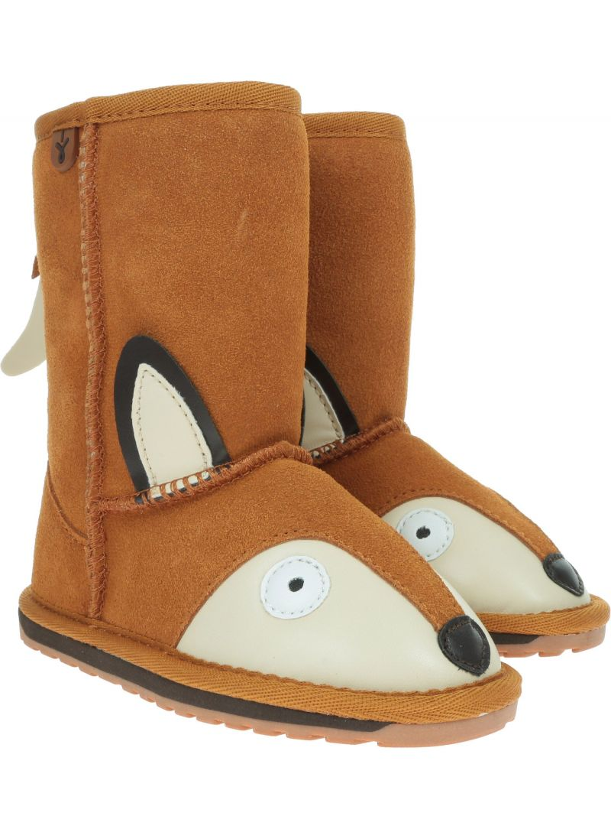

|  |  |  |  |
| --- | --- | --- | --- |
| B | U | T | Y |

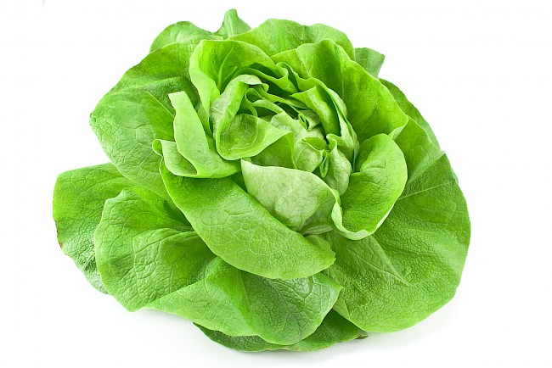

|  |  |  |  |  |  |
| --- | --- | --- | --- | --- | --- |
| S | A | Ł | A | T | A |

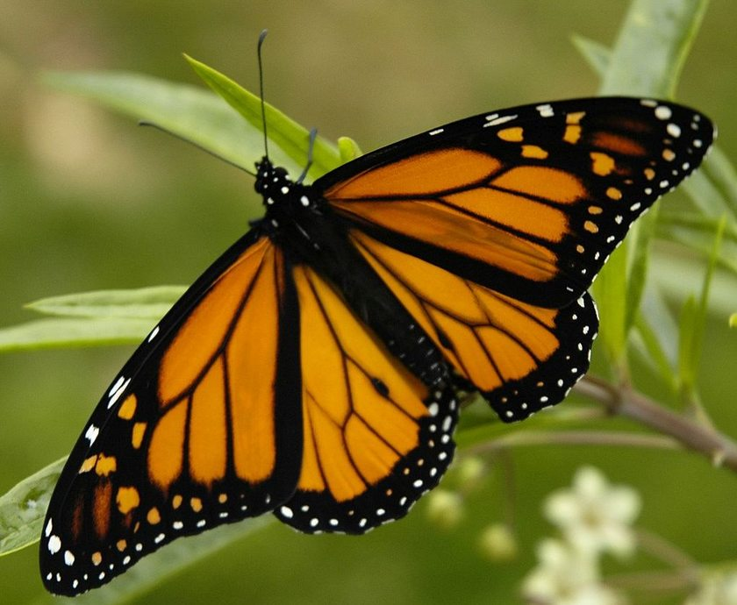

|  |  |  |  |  |
| --- | --- | --- | --- | --- |
| M | O | T | Y | L |

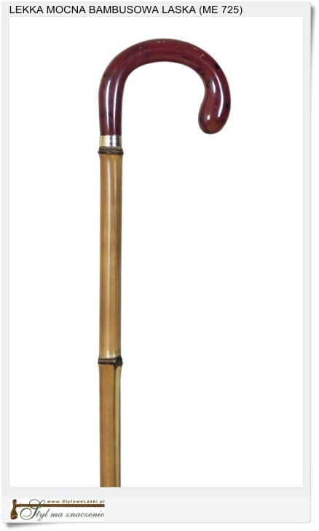

|  |  |  |  |  |
| --- | --- | --- | --- | --- |
| L | A | S | K | A |

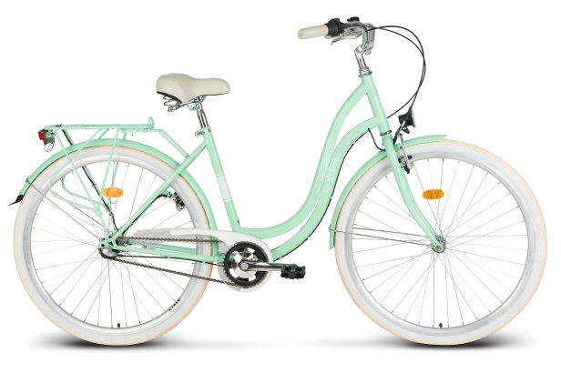

|  |  |  |  |  |
| --- | --- | --- | --- | --- |
| R | O | W | E | R |

|  |
| --- |
| Burak - wartość odżywcza i właściwości lecznicze - Natura Plus Zdrowie |

|  |  |  |  |  |
| --- | --- | --- | --- | --- |
| B | U | R | A | K |

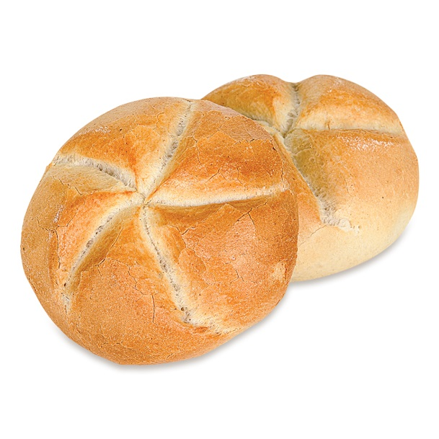

|  |  |  |  |  |
| --- | --- | --- | --- | --- |
| B | U | Ł | K | A |



|  |  |  |  |  |  |
| --- | --- | --- | --- | --- | --- |
| P | R | A | L | K | A |



|  |  |  |  |  |  |  |
| --- | --- | --- | --- | --- | --- | --- |
| P | A | P | R | Y | K | A |

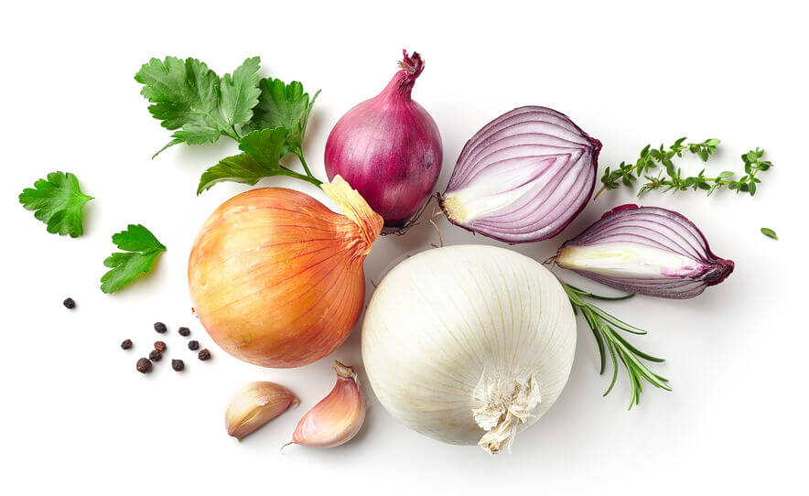

|  |  |  |  |  |  |
| --- | --- | --- | --- | --- | --- |
| C | E | B | U | L | A |



|  |  |  |  |  |
| --- | --- | --- | --- | --- |
| O | W | O | C | E |

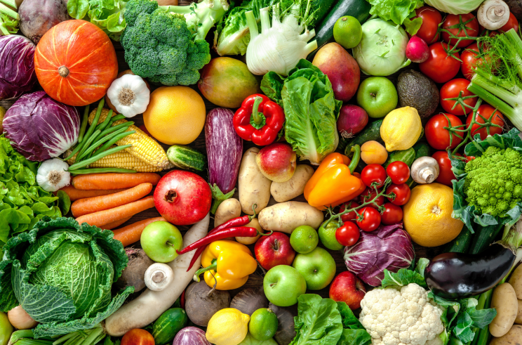

|  |  |  |  |  |  |  |
| --- | --- | --- | --- | --- | --- | --- |
| W | A | R | Z | Y | W | A |